***RANGE PARTITIONING***

Partitioning

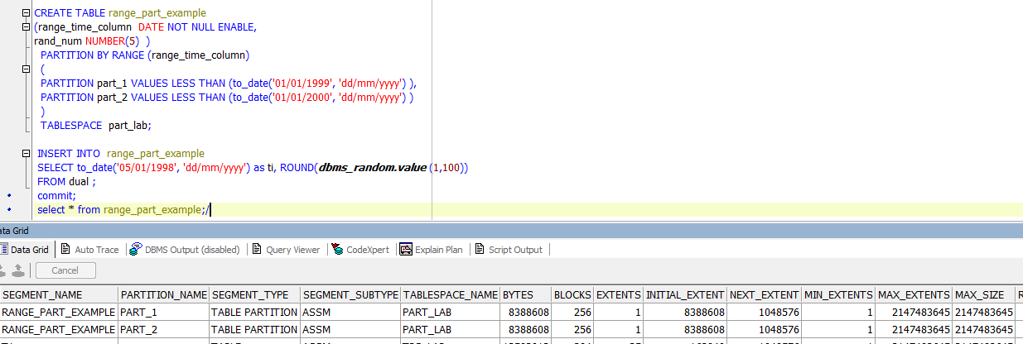

[Adding Partitions](http://docs.oracle.com/cd/B28359_01/server.111/b32024/part_admin.htm#i1007318)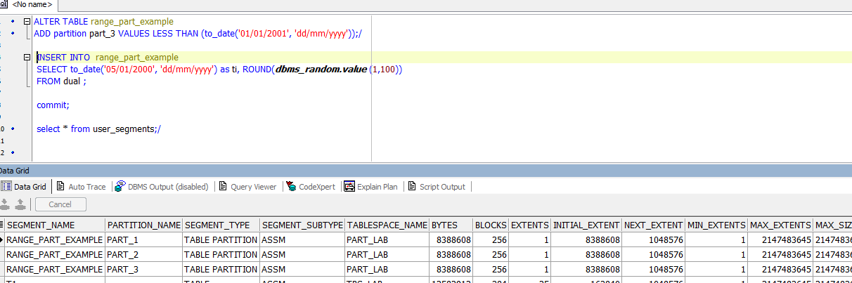

[Merging Partitions](http://docs.oracle.com/cd/B28359_01/server.111/b32024/part_admin.htm#i1007638)

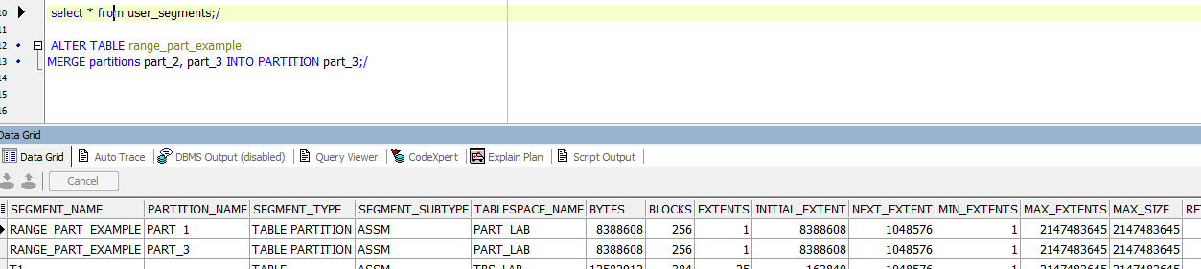

[Splitting Partitions](http://docs.oracle.com/cd/B28359_01/server.111/b32024/part_admin.htm#i1008028)

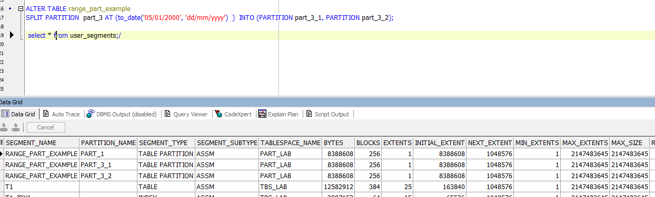

[Moving Partitions](http://docs.oracle.com/cd/B28359_01/server.111/b32024/part_admin.htm#i1007920)

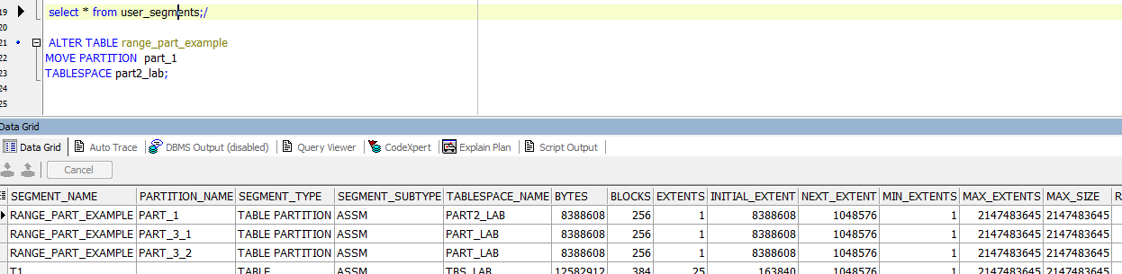

[Truncating Partitions](http://docs.oracle.com/cd/B28359_01/server.111/b32024/part_admin.htm#i1008226)

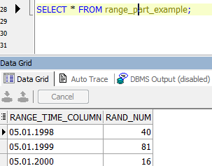

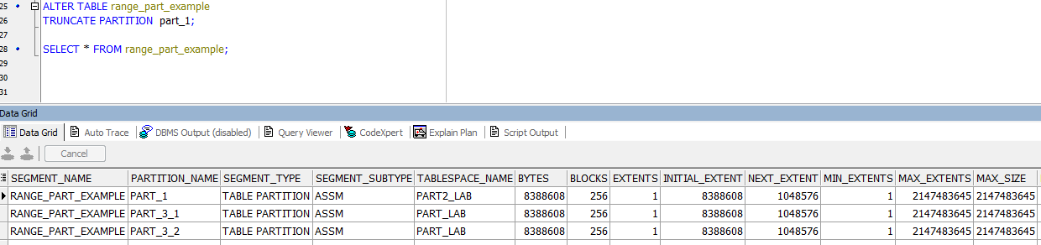

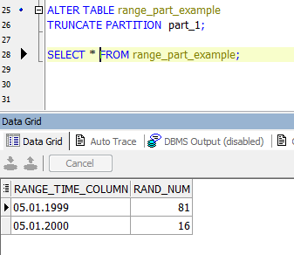

[Dropping Partitions](http://docs.oracle.com/cd/B28359_01/server.111/b32024/part_admin.htm#i1007479)

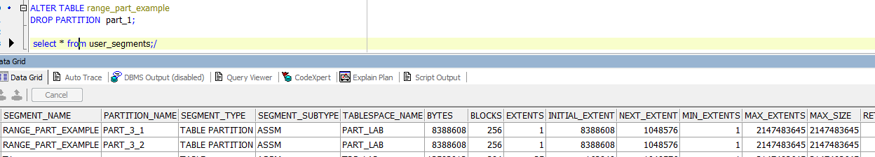

|  |
| --- |
| CREATE TABLE range_part_example  (range_time_column DATE NOT NULL ENABLE,  rand_num NUMBER(5) )  PARTITION BY RANGE (range_time_column)  (  PARTITION part_1 VALUES LESS THAN (to_date('01/01/1999', 'dd/mm/yyyy') ),  PARTITION part_2 VALUES LESS THAN (to_date('01/01/2000', 'dd/mm/yyyy') )  )  TABLESPACE part_lab;    INSERT INTO range_part_example  SELECT to_date('05/01/1998', 'dd/mm/yyyy') as ti, ROUND(***dbms_random.value*** (1,100))  FROM dual ;  INSERT INTO range_part_example  SELECT to_date('05/01/1999', 'dd/mm/yyyy') as ti, ROUND(***dbms_random.value*** (1,100))  FROM dual ;  commit;  select * from range_part_example;  ALTER TABLE range_part_example  ADD partition part_3 VALUES LESS THAN (to_date('01/01/2001', 'dd/mm/yyyy'));/    INSERT INTO range_part_example  SELECT to_date('05/01/2000', 'dd/mm/yyyy') as ti, ROUND(***dbms_random.value*** (1,100))  FROM dual ;    commit;    select * from user_segments;    ALTER TABLE range_part_example  MERGE partitions part_2, part_3 INTO PARTITION part_3;/  ALTER TABLE range_part_example  SPLIT PARTITION part_3 AT (to_date('05/01/2000', 'dd/mm/yyyy') ) INTO (PARTITION part_3_1, PARTITION part_3_2);  select * from user_segments;/    ALTER TABLE range_part_example  MOVE PARTITION part_1  TABLESPACE part2_lab;  ALTER TABLE range_part_example  TRUNCATE PARTITION part_1;  SELECT * FROM range_part_example;  ALTER TABLE range_part_example  DROP PARTITION part_1;  select * from user_segments;/ |

***HASH PARTITIONING***

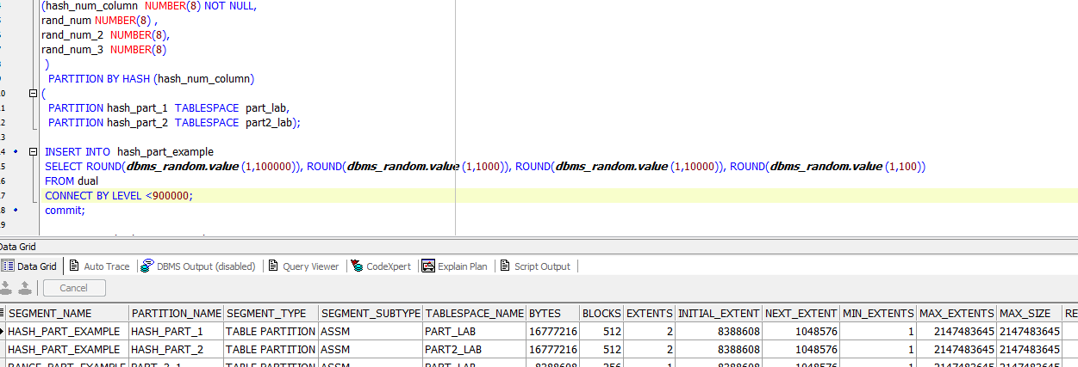

[Adding Partitions](http://docs.oracle.com/cd/B28359_01/server.111/b32024/part_admin.htm#i1007318)

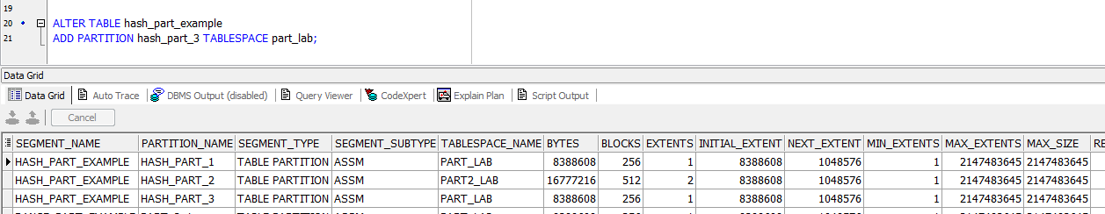

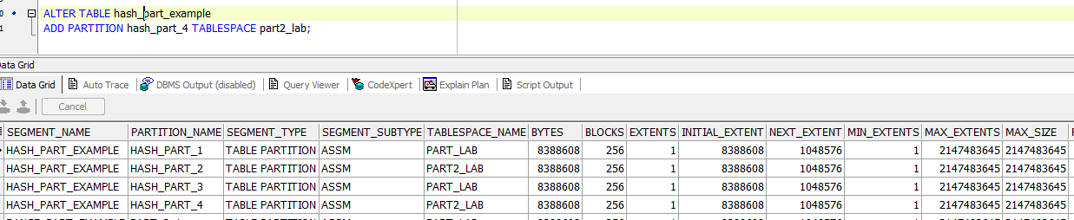

[Coalescing Partitions](http://docs.oracle.com/cd/B28359_01/server.111/b32024/part_admin.htm#i1007442)

